Workflow of Gateway Student Option Module for IB Subjects
- Setup Form
  - Admin > Forms (refer to page 2)
You may turn on/off for some option according to your school’s need, e.g. questions, teacher’s recommended pathway, parent confirmation process, parent’s comment
  - Input teacher’s recommended pathway (optional)
Allow on screen input or import by csv (Excel)
  - Add subjects
Add from Maze subjects or create new subjects
  - Add subject rules
There are built-in rules and allow user setup rules e.g. subject prerequisite, conflicting subject (WON’T COVER all RULES)
- Students submit form
System checks the select basis on rule setup and give warnings. It will
allow go ahead with warnings and print warning messages on the form for checking
- Parents confirm form (optional)
Click a button to confirm and stamp the confirmation date
- Verify forms by coordinator/subject teacher
  - Verify in roll group view
  - Verify in subject view
- Export csv for Maze import (TBC)
- Reports (TBC)

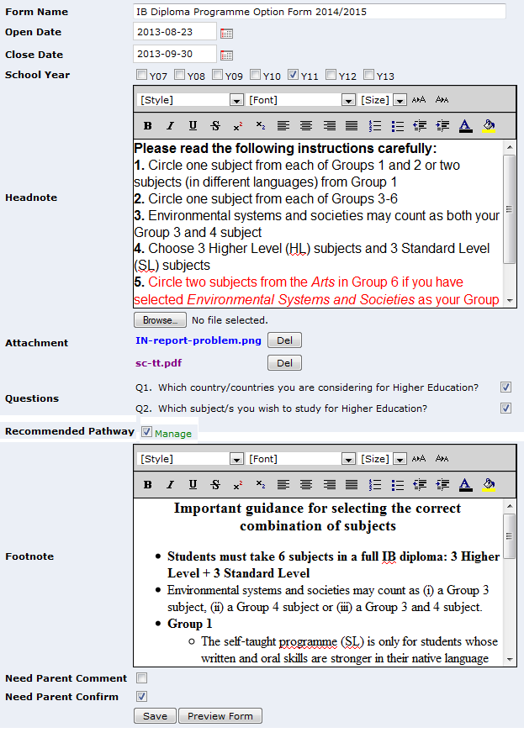
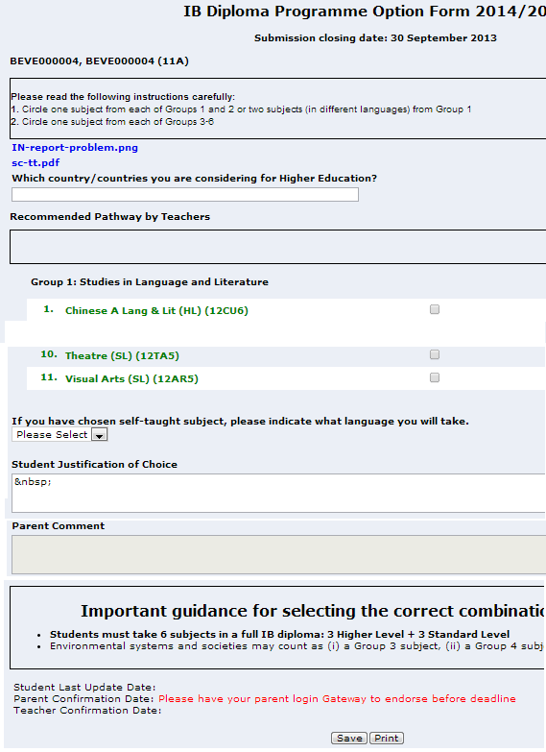
  - Setup form Option Form vs Forms setting page

- Input teacher’s recommended pathway (optional)  You to enable this option under Forms setup screen:  - Input recommended pathway on screen  Student List click on a roll group name, there is a text box column to input Recommended pathway for each student  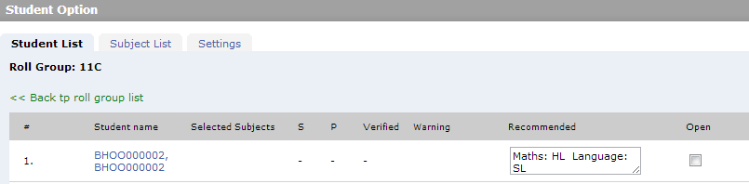  - Import with csv  Download Template and input recommendation to the last column, save as a new csv file to your computer.  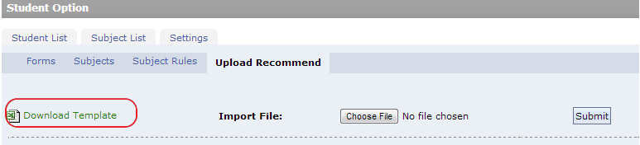  Submit the saved csv file, you may preview the change before confirm importing it. Please note the meanings of background colours.  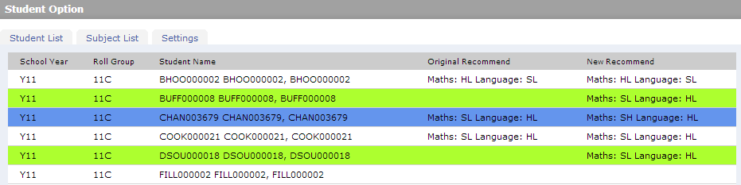  - Add subjects  You may add subjects to group under Subjects tab. It is possible to select from Maze subject or create your own subjects for selections. You may change the subject display name, and add subject Remarks which will be display on the option form next to the subject name. | 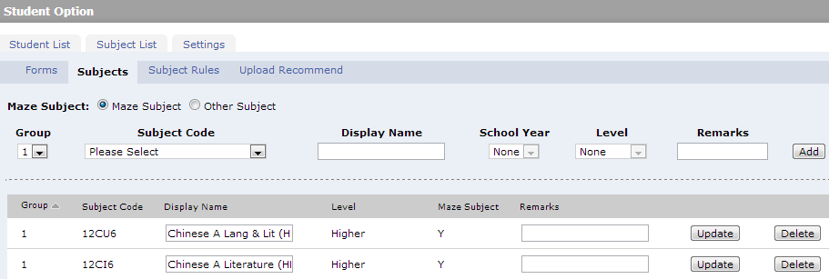  - Subject rules setup  There are some built-in rules, e.g. not allow duplicated subjects; have to select subject before submit; recommend 3xHL & 3xSL. On top of these, user may setup additional subject rules.  conflicting subject rules. e.g.  -Theatre cannot be taken if you have chosen Lierature and performance  -ESS cannot be taken with Biology  -cannot take two ab initio languages e.g. ltalian+Japanese  prerequesit subject rules. e.g.  - subject A requires sbubject B  - subject A&B must be taken together  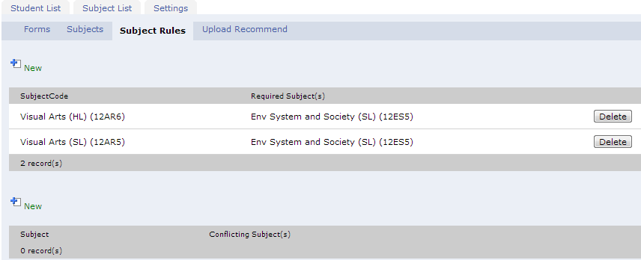  However, the system canot handle all subject option rules. it requires further checkings by staff. The system provide a list view for easier checking.
- Student submit form  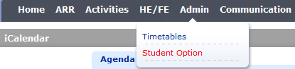  - Fill in the form and click Submit, there will be a confirmation of selected subjects.  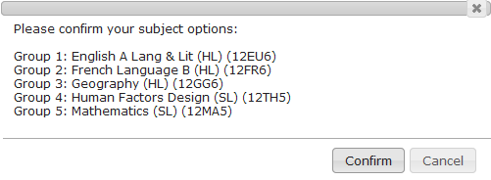  - Click Confirm, if there is any error detected, it will prompt and list the warnings. It allows ignore warnings and go ahead to submit, or cancel to correct input and resubmit  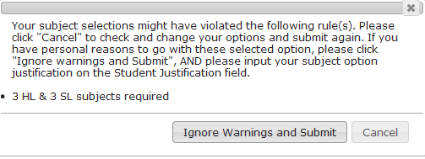  - The warning will be printed on the form, it is viewable by Student/Parent/Staff  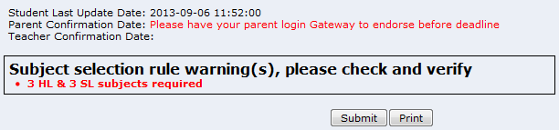  - If parent confirmation is required by option form settings, it will display a message in red also, if not “Parent confirmation date” above will be hidden. |  | - Parent confirm  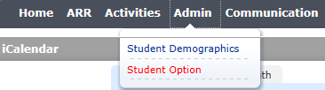  - Select child’s name to open the option form  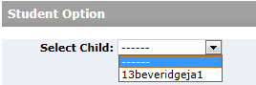  - Optional fill in parent comment (depends on form settings)  - After student submitted the form, Parent will have the “Confirm” button, click on it, the date time will be add to the form  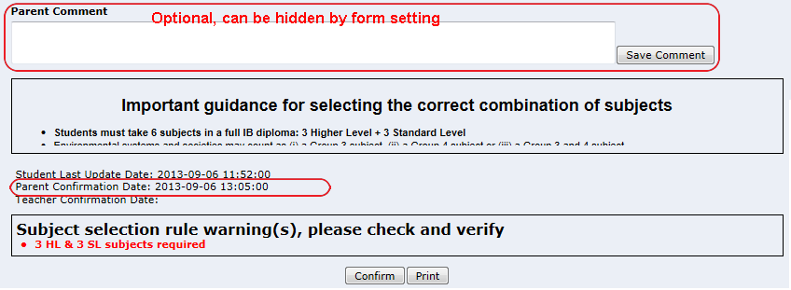  Note:  Before closing date, student may make changes to the form anytime (click submit again), if parent has already confirmed and student submit again, it will clear the parent confirm date stamp and student should inform parent to login and confirm the update. There will be a warning message to student for this case.  After closing date, both the forms are read only to student and parent, until coordinator/teacher re-open the form in two ways:  - Only open specify students’ forms  - Extend the closing date to open for all students

- Verify forms by coordinator/teacher  - Coordinator’s view - Student List screen  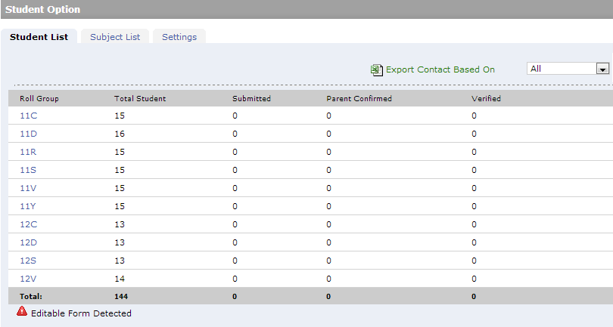  - Student List is a submission status overview by roll group / (tutor group for RC) view  - If the numbers of Submitted (by student), Confirmed (by parent), Verified (by school) reach the total no. of students, it indicates the completion of that roll group and will display in green.  - There will be an icon shown next to the roll/tutor group name if there is open for edit form(s) after deadline.  - You may click on the Roll/Tutor Group name to open the form list of the roll/tutor group as below. It provides a status overview of the roll/tutor group.  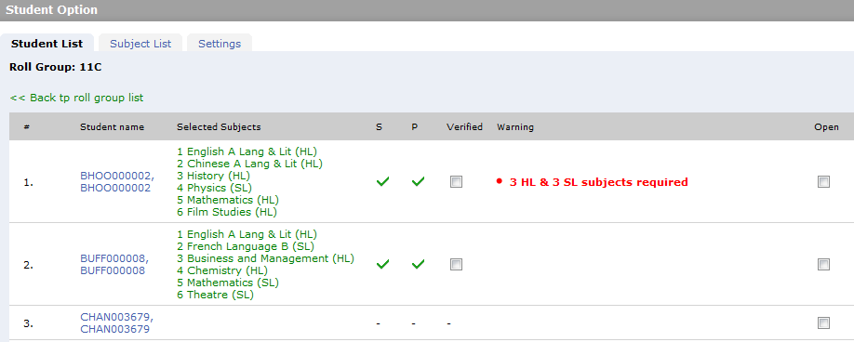 | - S indicates student submission status  - P indicates parent confirmation status (if required)  - Verified check box for user to batch update status  - Warning shows the problems detected in the form (user should verify the Selected Subject even if there is no warning detected.  - Open to manually open the form for student/parent due to change need  - Save DON’T FORGET to save your work on this page!  - When necessary, you may click on the Student Name to open a student option form. You may give comment to the form here:  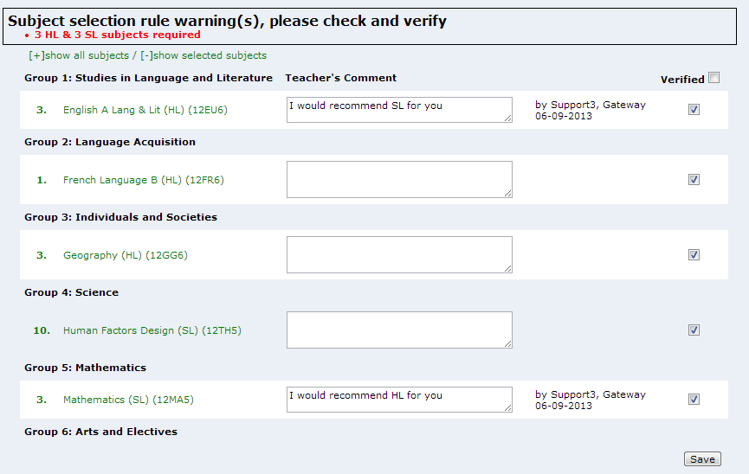  - User may input comment on the form and click Save. Both student and parent will see the teacher’s comment.  - If all subject selections are good, user may lick Verified all box and click on Save. If there is one subject is not “verified”, this form is not verified in upper level.
- Student view teacher’s comment on the form  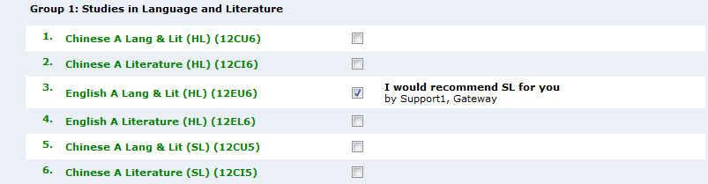  - Subject Teacher’s view - Subject List screen  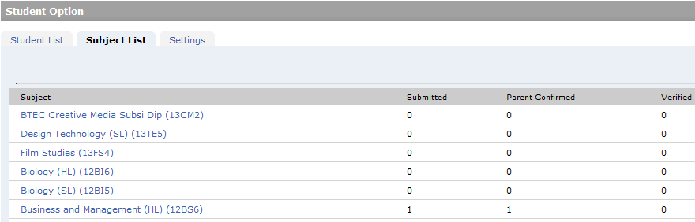  - Provides another view for subject teachers to verify the subject selections by subject view.  - Click Subject name to open the list of students who have selected the subject:  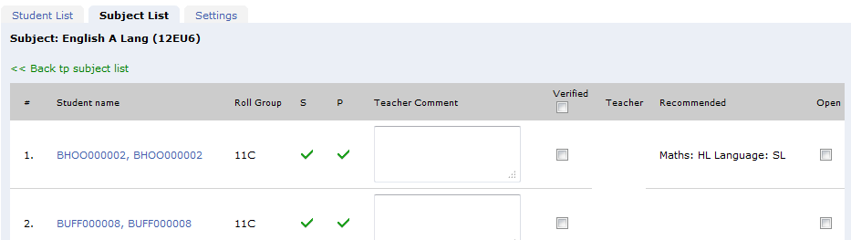 | - Teacher may input comment if necessary  - Teacher may Confirm/verify the student’s selection of this subject  After deadline, user may re-Open the form to student/parent for further changes when necessary.

