Typical Usage of Gateway eNotice

Gateway eNotice can help streamline the data collection and distribution for parents and students, e.g. collect consent form, event registration, distribute notice, documents etc. This document shows some typical scenarios of eNotice to help colleagues to understand how to utilise this online tool for effective data distribution and collection. Should you wish to have trainings or feedback on the improvement of eNotice. Please email KK Kong kk.kong@esfcentre.edu.hk .
Some typical scenarios on setup eNotice
- Parent Consent requires medical information update
- Parent Consent requires fee collection
- Distribute information/document
- Starter pack for new parents
- Information pack for existing parents at year/term start
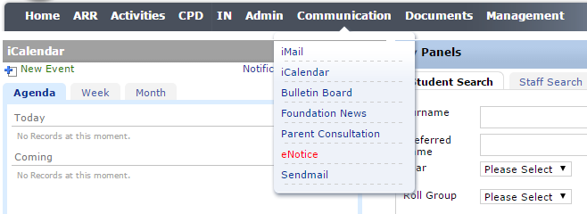

Parent consent form requires medical information update
This is a typical setup to give trip arrangement information to parents whose child has enrolled a trip. It requires the parents to 1) give consent 2)confirm the Gateway medical information is up to date, and 3) provide emergency contact during the trip:
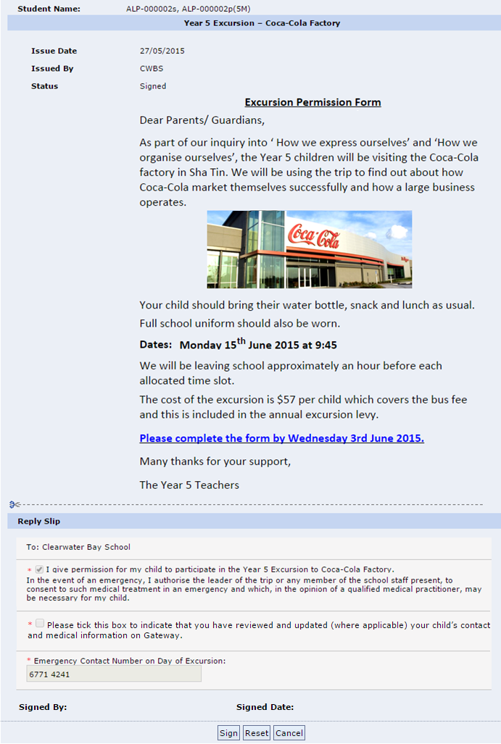

Parent consent form requires fee payment

Case #1: If your school use ePayment module which requires parents to pre-deposit money for activities fee payment. You may setup the ePayment Balance Checking in order to sign the consent form. (Please consult ESFC project team if you wish to enable this function)
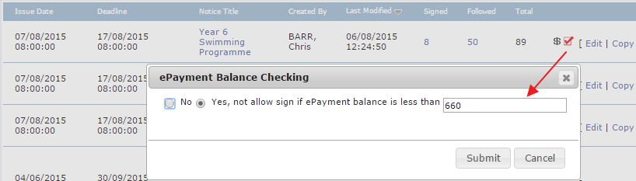
If student’s ePayment account has insufficient balance, it will display a warning message in red and no Sign button on the eNotice, see screen below. Parent then need to top up the ePayment balance first before sign the consent.
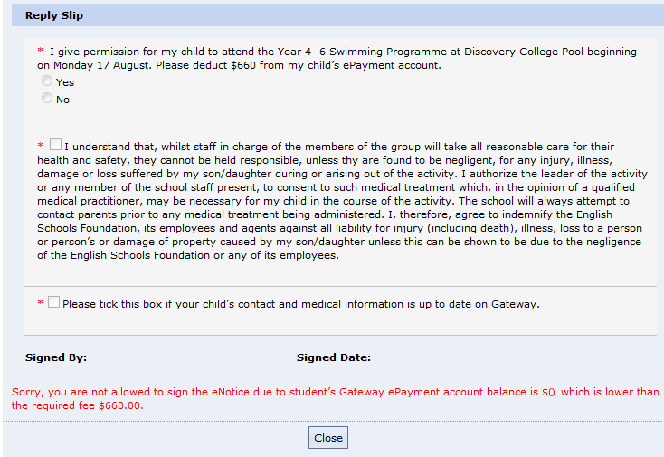

Case #2: If your school collect cheques for activities payment you can simply add the bank name and cheque number to the reply slip, so parents have to prepare a cheque when they sign the eNotice. e.g.
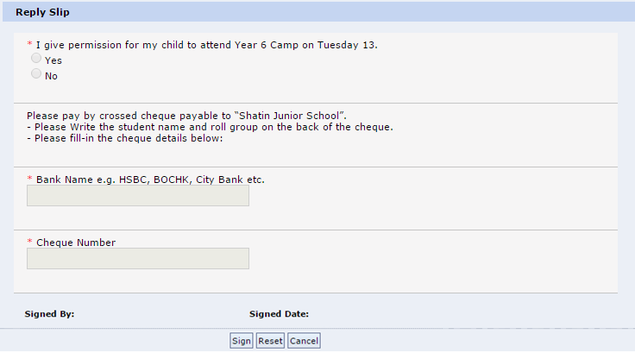

Distributing document/information that needs acknowledgment of receipt
Add the attachment(s) to the eNotice, and add a mandatory checkbox to show acknowledgment . Parent are required to tick checkbox and click sign button.
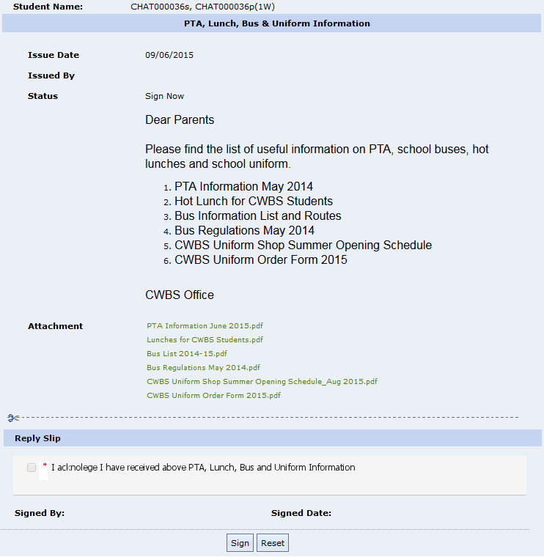

More eNotice samples
The following eNotice & reply slip are captured from some schools for reference only
Permission form (charge the ePayment)
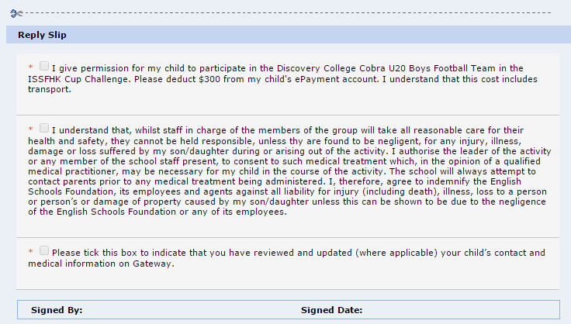
Permission form sample
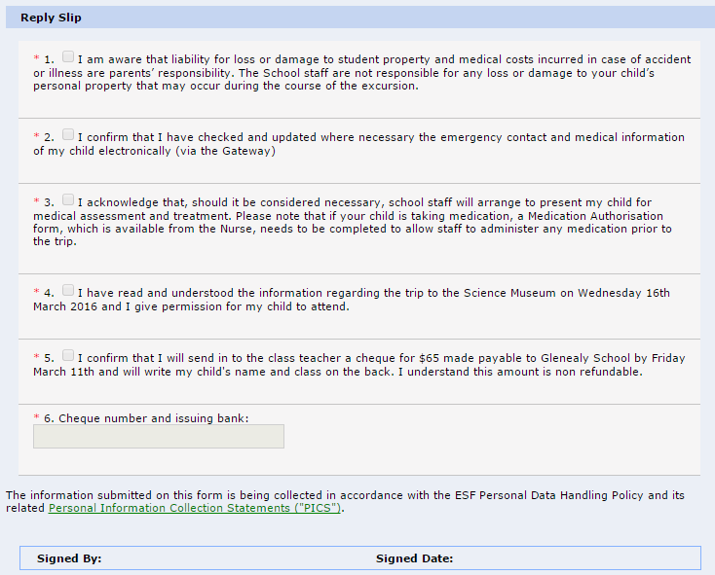
Trip Leader administer medicine authorisation
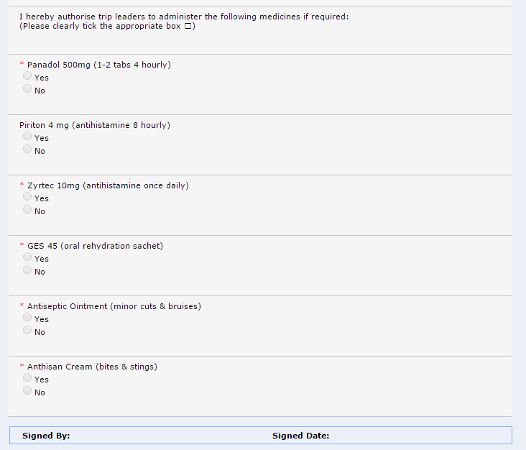

Reminder need acknowledgement
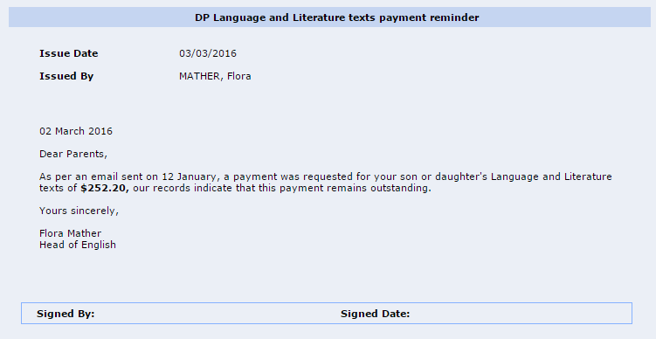

Permission form with more details
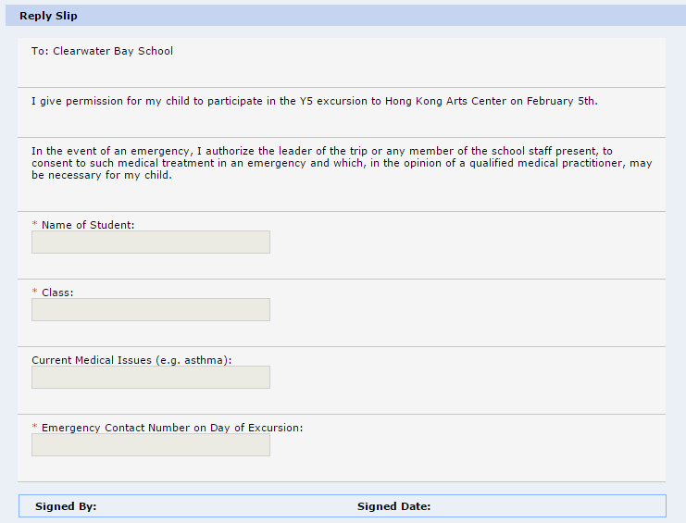
PAT membership registration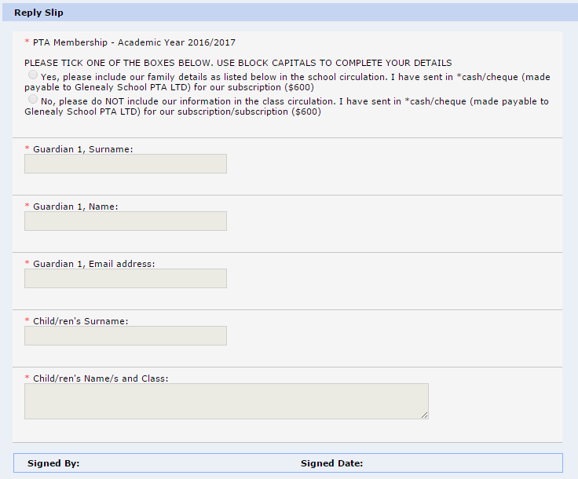
Go home arrangements (this can be done via the standard CR from “After School Collection Arrangement”)
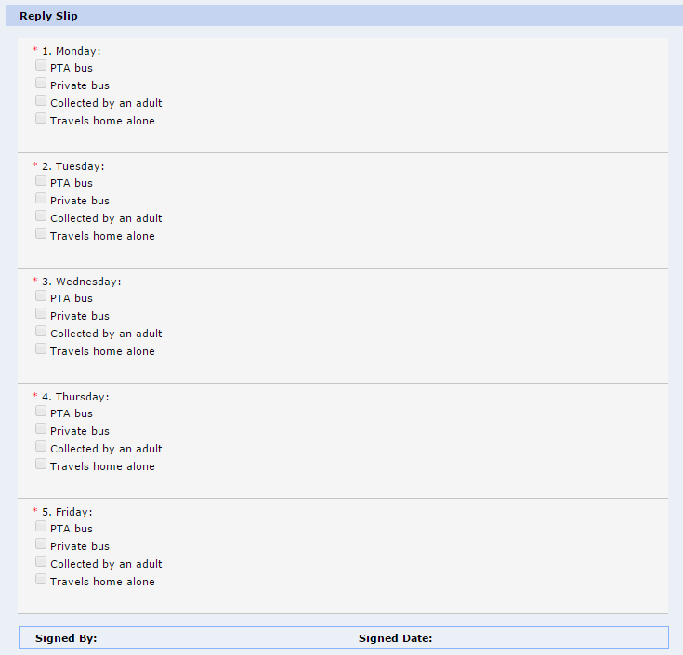
Permission form
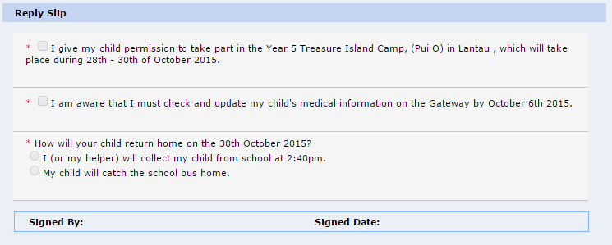

Choose your friends
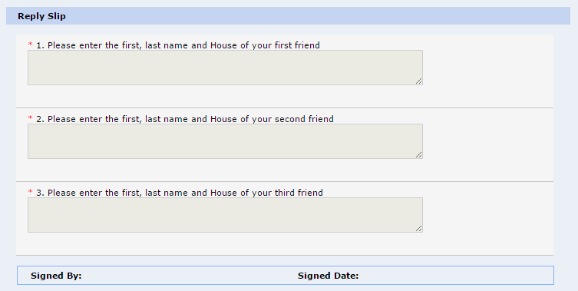

Policy Agreements 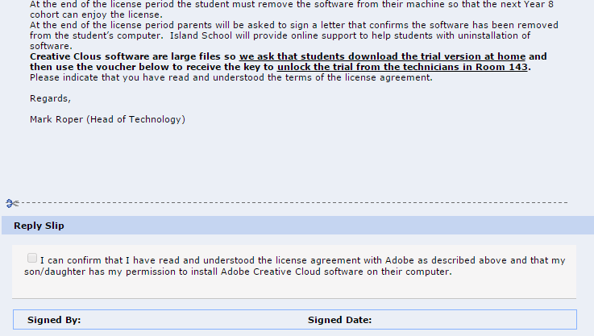

eNotice content with external links for reference
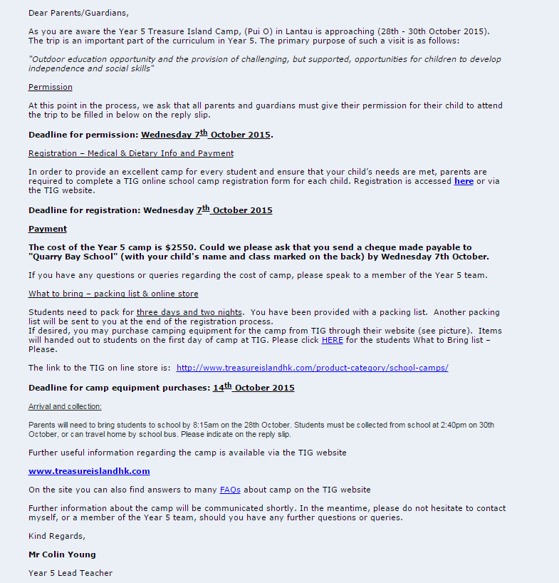

Starter pack for new parents
School may distribute the starter pack to new parents via the Information Pack. An information pack is a batch of eNotices, when parents first login Gateway, it will pop up a full screen to show the pack and all the eNotices need parent to sign.
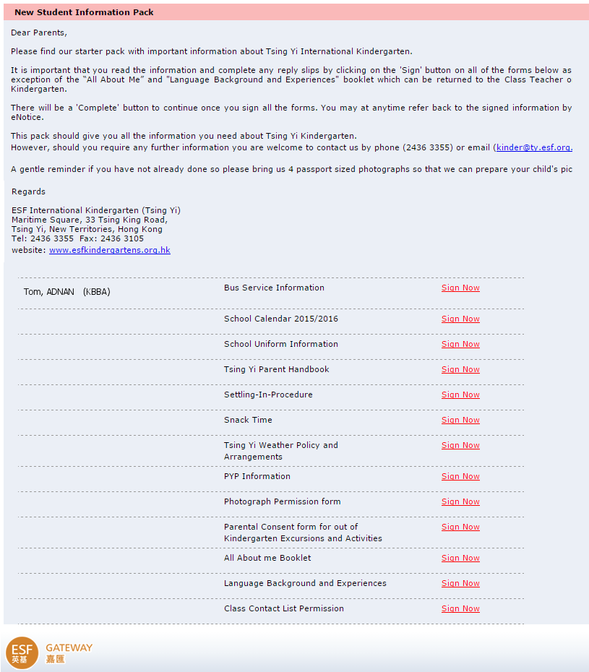

Information pack for existing parents at year/term start
Similarly, you may issue information with a batch of eNotice to existing parents at each year start/term start if you need to distribute forms and document to them. Then invite them to login Gateway at the beginning of the year/term to receive the pack the fill in forms on Gateway.

