Gateway Y7 Transfer Form - Administrator User Guide

Administrator turns on the Y7 Transfer form
Admin > Change Request Management > Settings
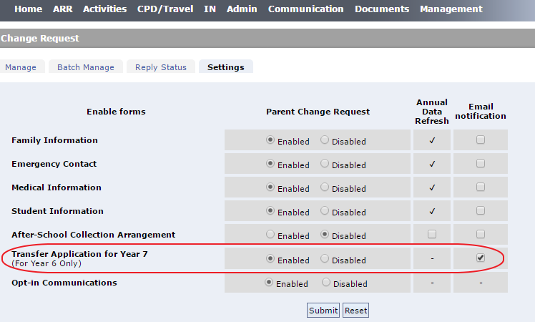
Select Enable to turn on the form on your school Gateway.
IMPORTANT: Y6 Parents are allowed to submit the “Transfer Application for Year 7” ONCE ONLY for each student. So there is no issue to keep the form enable before the deadline, parents won’t be able to re-submit it. However, please remember to disable the form latest by the end of the year, so that next year Y7 parents won’t be able to submit the form before the scheduled open date.

Manages the submitted forms
Admin > Change Request Management > Settings
Select school year, Pending status and the form type to be Transfer Application for Year 7:
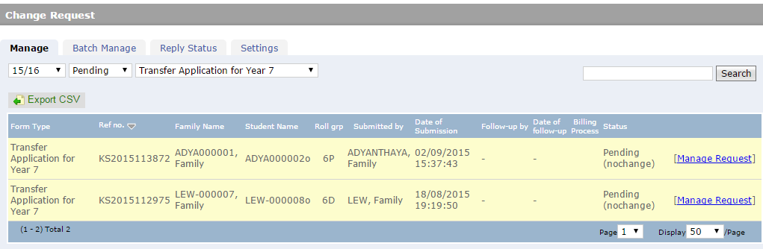
Click on “Manage Request” to open a form:
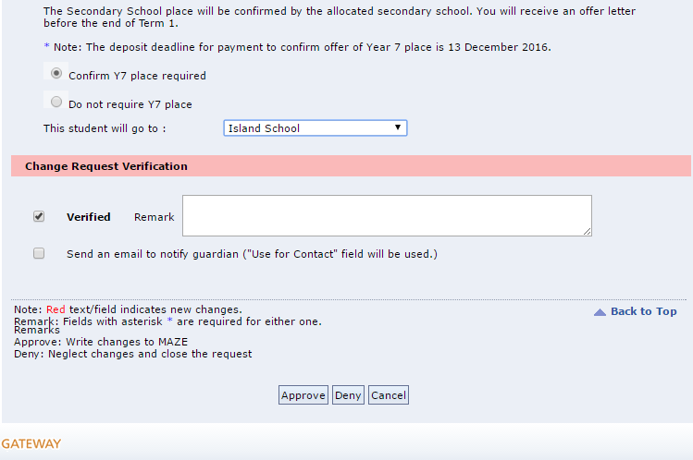
- Verify the data, any changes of contact information will be shown in Red.
- Input the destination school if student requires Y7 place
- You need to tick Verified checkbox
- It is optional to send email to the parent
- Click Approve/Deny to complete the process
- Once processed, you may find the Approved/Denied records.
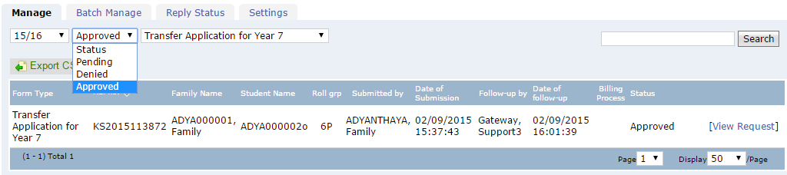
If you wish to find out who haven’t submitted the form, you may export the list to csv and sort it by roll group and name to sort out who are not in the list:
